**Big Mountain Resort Report**

__________________________________________

**Problem Statement**

The business problem is that we need to increase seasonal revenue at Big Mountain Resort (BMR) enough to offset the recent increase in operational costs due to the addition of a brand-new chair lift that cost $1.54M to implement. The overall focus was put on finding ways to cut down on costs without undermining ticket value or justify setting higher prices for tickets.

**Data**

The data used throughout the project was a CSV file acquired from Alesha Eisen, the database manager. The file contained 330 resorts within the same market in the United States, including data for BMR. The features of the data are listed below:

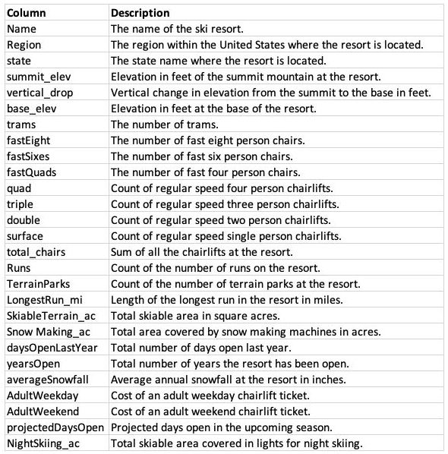

**Analysis Findings**

After testing several different models on predicting ticket price, we determined that the best performing one was our random forest model. During our analysis, we found that among the most important features that can help us predict ticket price are the number of fast four person chairs, count of runs on the resort, snow making area coverage, and vertical drop. It was determined that no additional data is needed to move forward.

We deduced that BMR lies amongst the top resorts in many amenities offered, and because of this can afford to raise the ticket price slightly. Below are the histograms pertaining to the features mentioned above that represent the counts of all the resorts included in our data and where they fall relative to BMR:

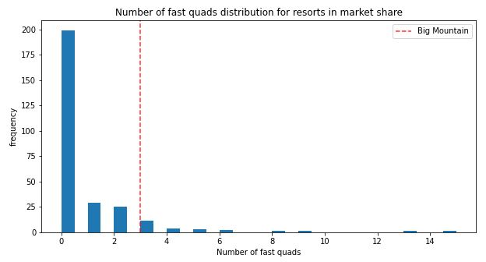

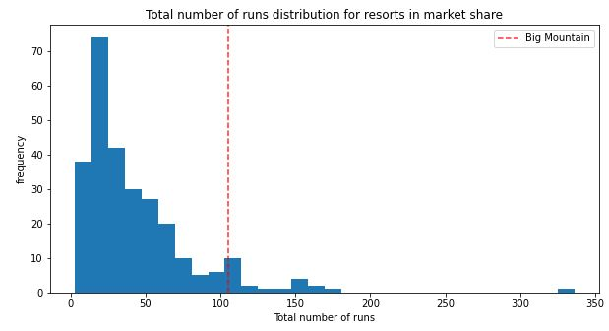

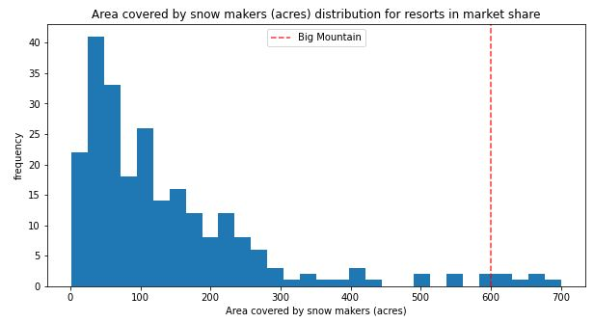

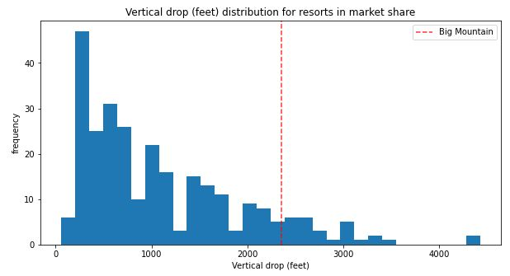

**Recommendations**

Our analysis tells us that Big Mountain Resort should slightly raise their price due to being in a high percentile of amenities offered in the market. Of the scenarios provided by the business, I would recommend implementing the second, which involved adding a run and a chairlift, as well as increasing the vertical drop by 150 feet. It is worth noting that if the business decides to move forward with this plan of action, we should look into how much the operational costs will increase with having to add to our facilities.